* Create 6 instances, 1 is master and another 5 is slaves

1. Open AWS Console and search for EC2

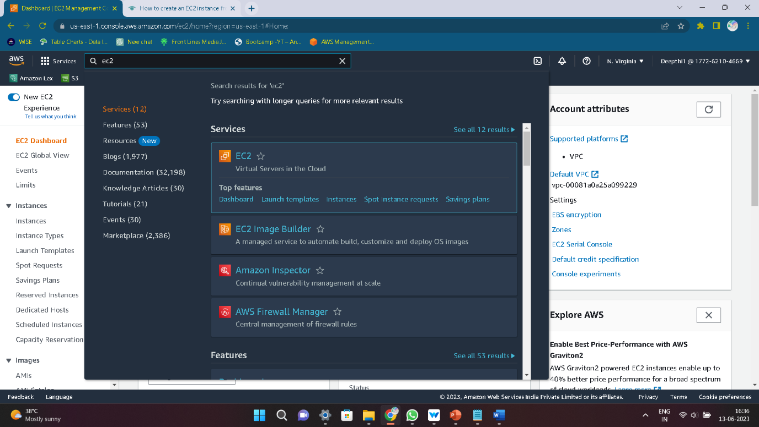

1. Click on Ec2 instance and after Launch the instance



1. Give a Name to the instance and select the Machine image and version

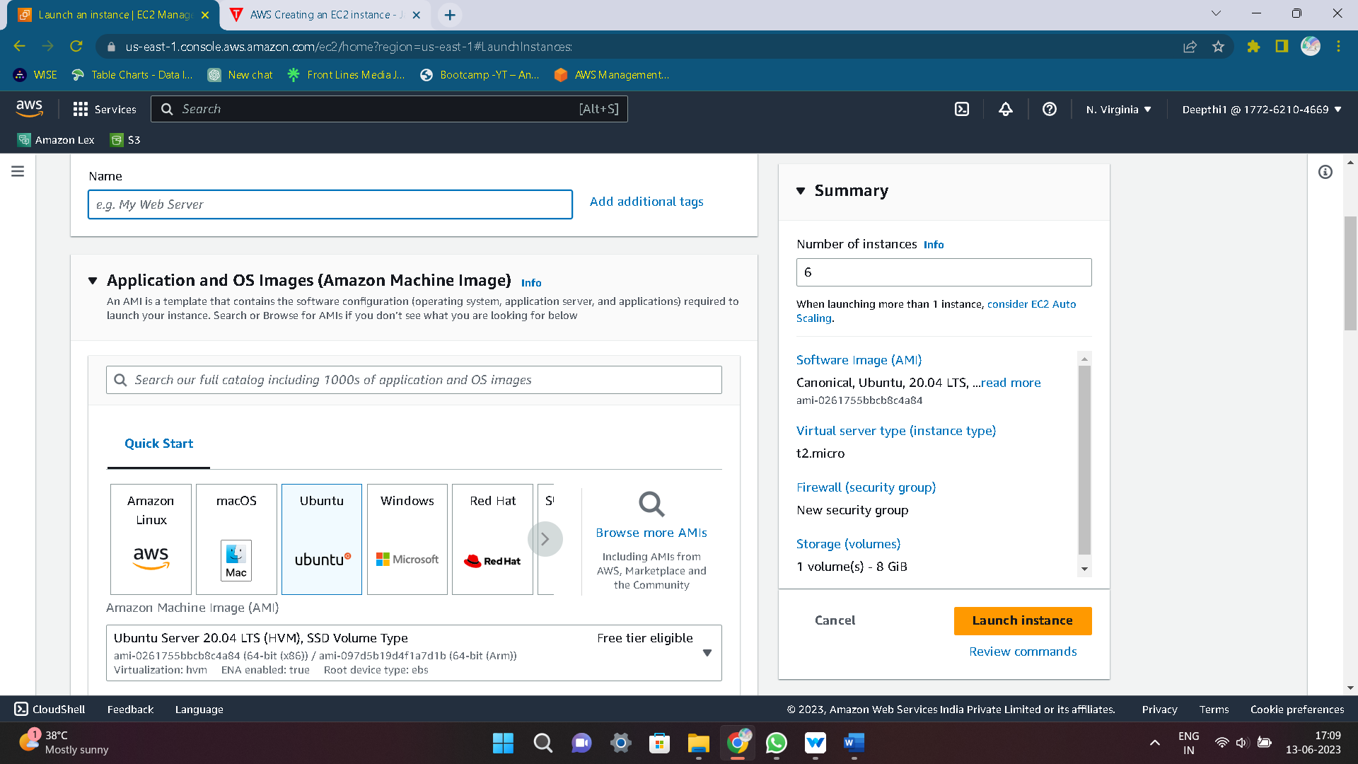

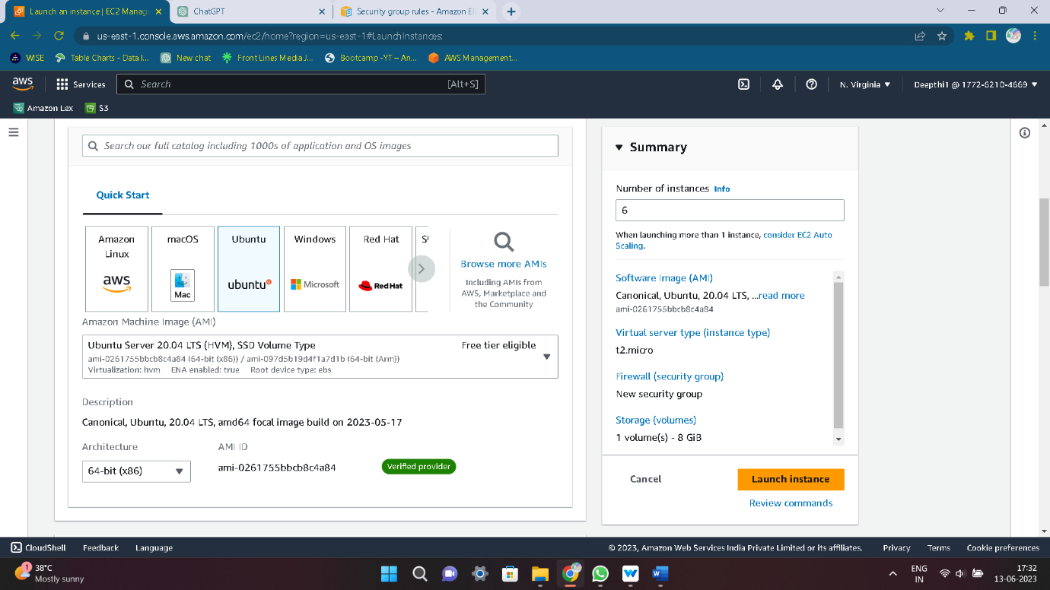

1. Select the Instance type t2.micro , t2.medium and select a keypair

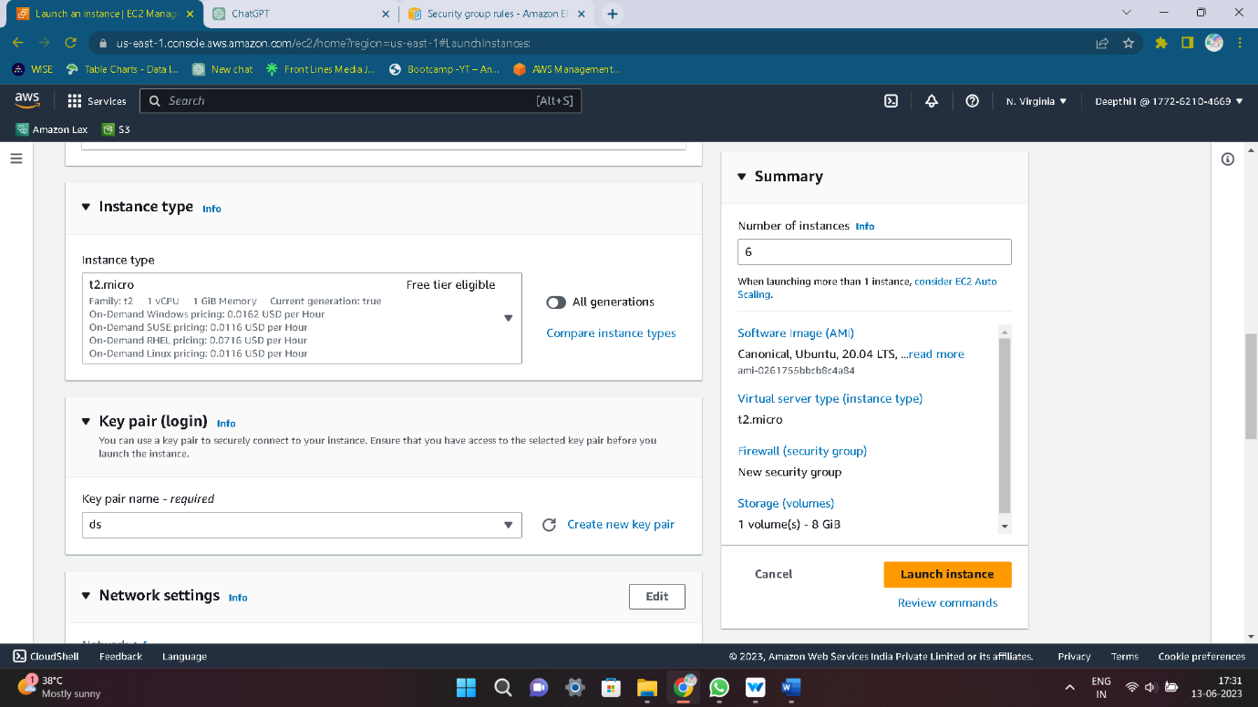

1. Configure the Network details and Build in security

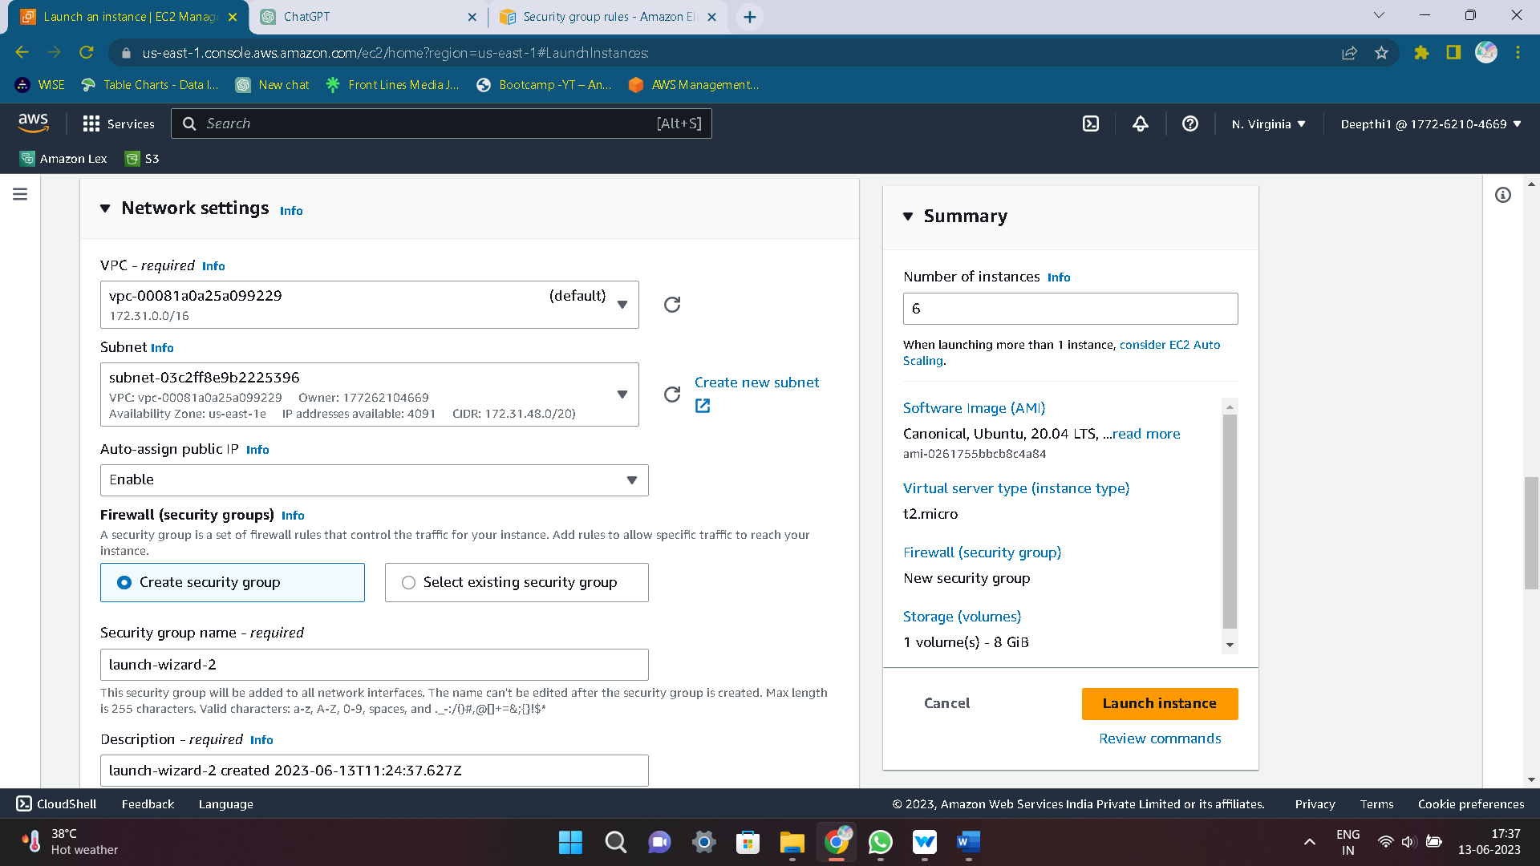

1. Config the Security group and give the port 22 in inbound rules for SSH and also Config the Storage

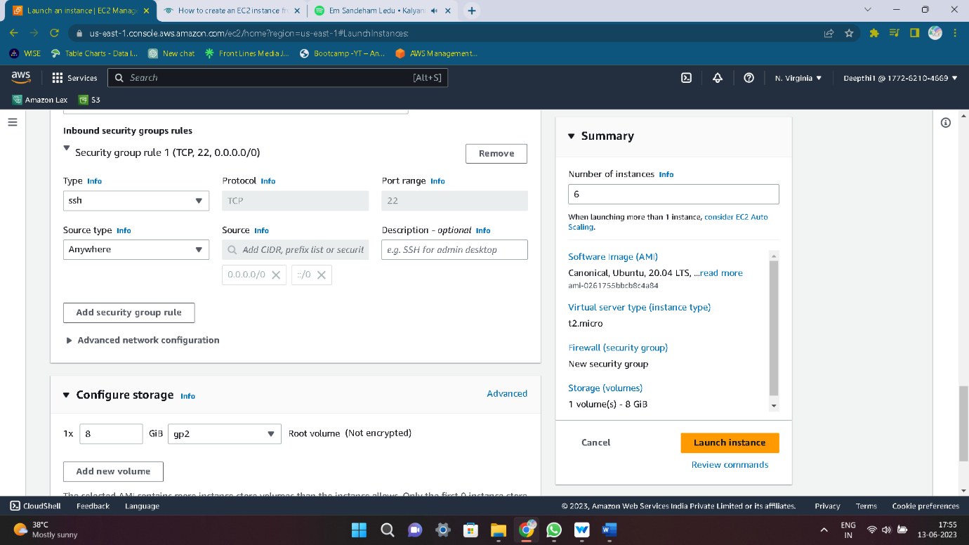

1. Now launch the Instance

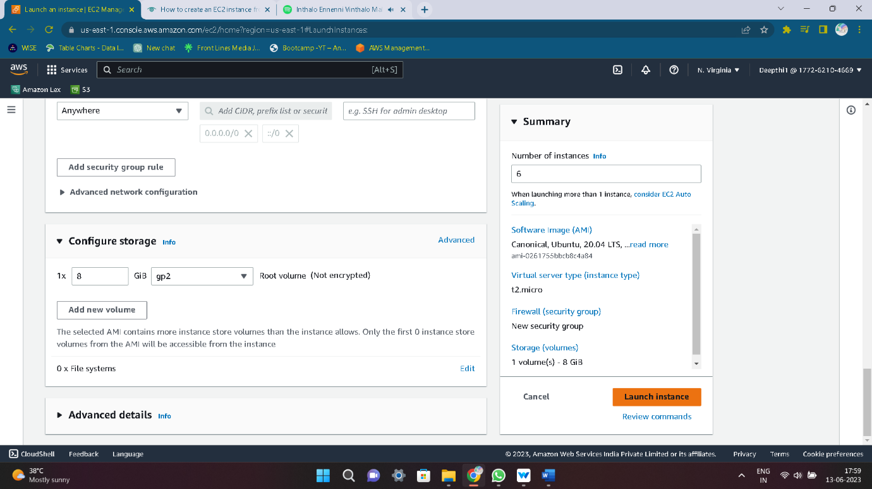

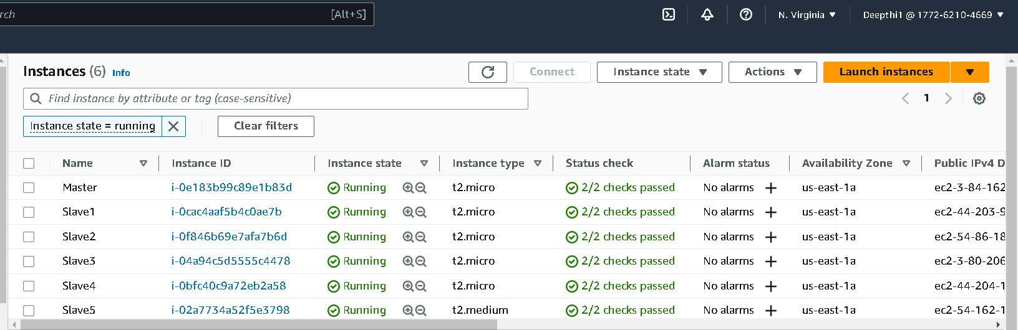

1. Connect the instance to the terminal

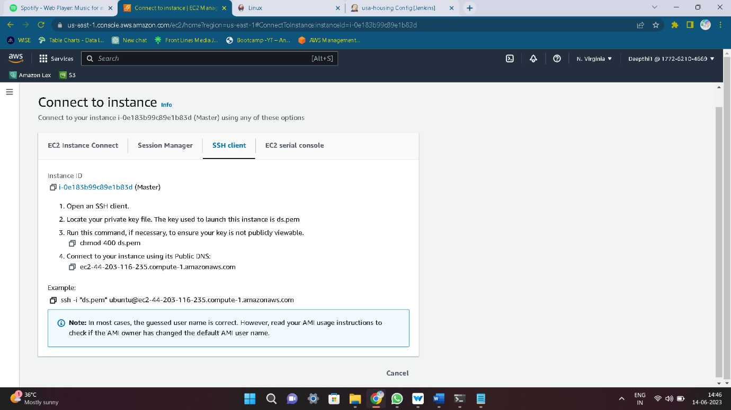

1. Open the terminal

* cd downloads/
* paste the SSH key and click enter and give the fingerprint YES

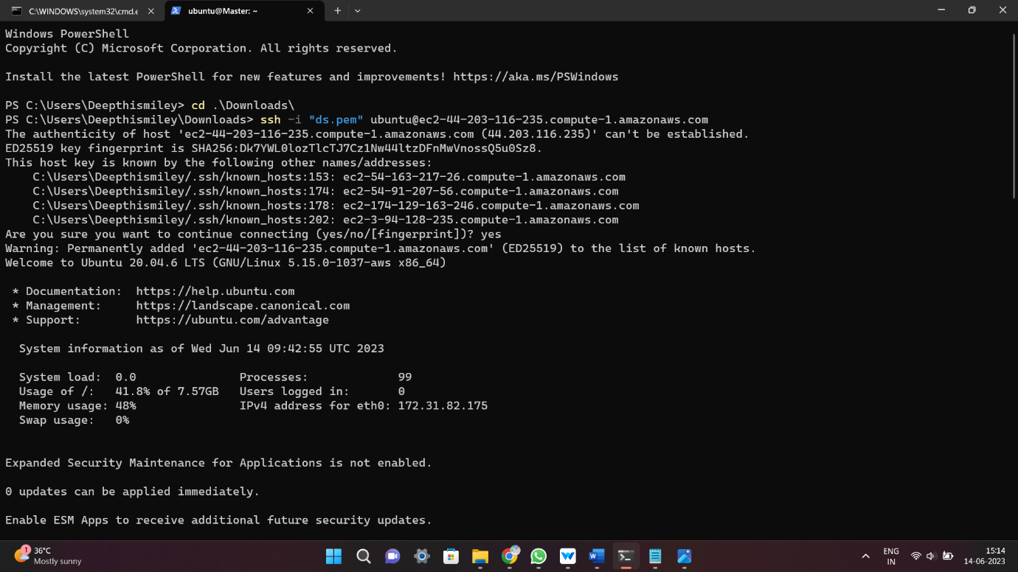

1. Change the hostname & restart the instance

* Sudo vi /etc/hostname
* Sudo init 6

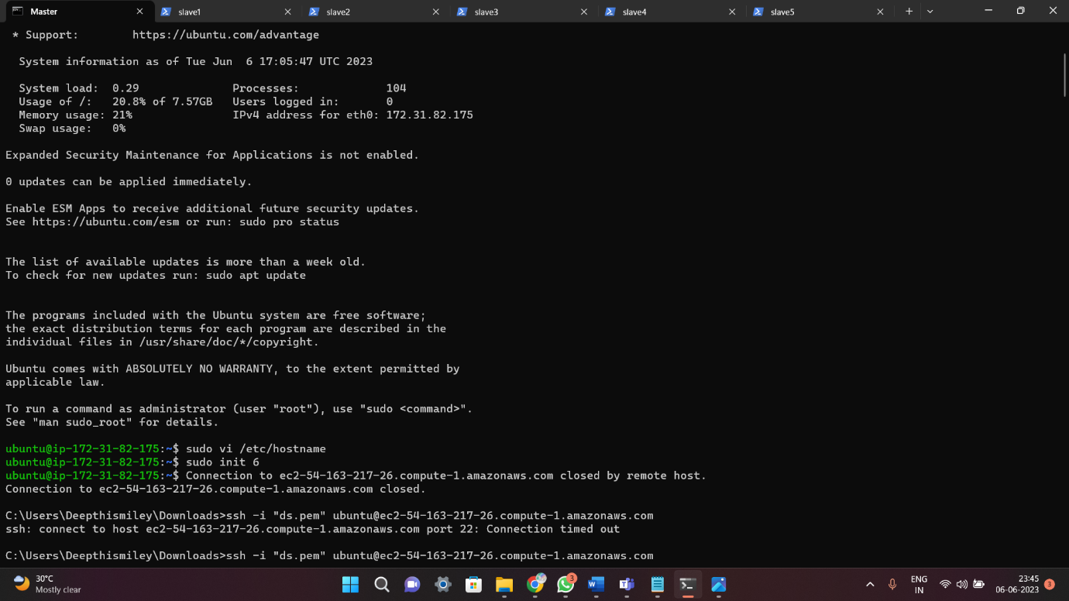

1. Update the instance and install some required packages

* Sudo apt update & full-upgrade

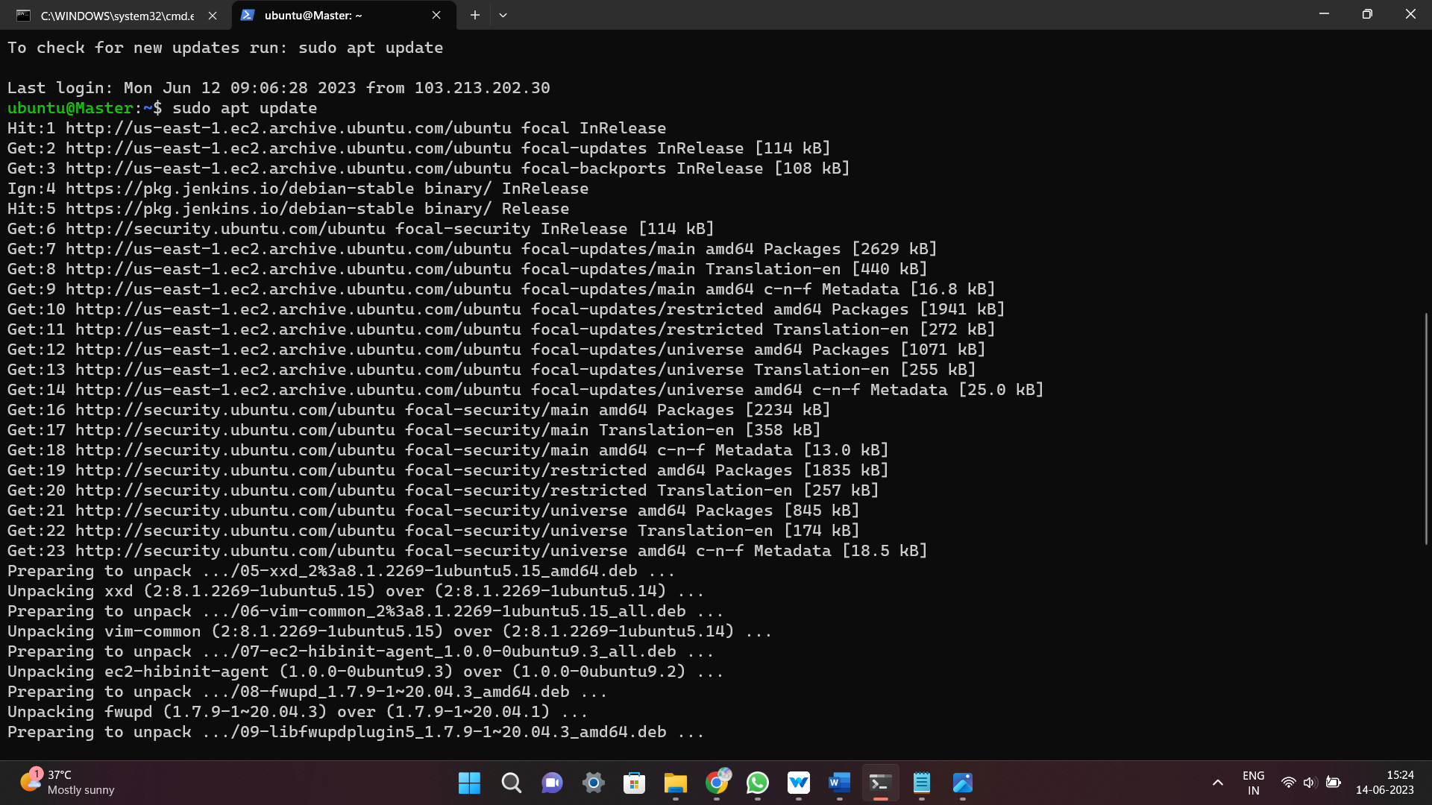

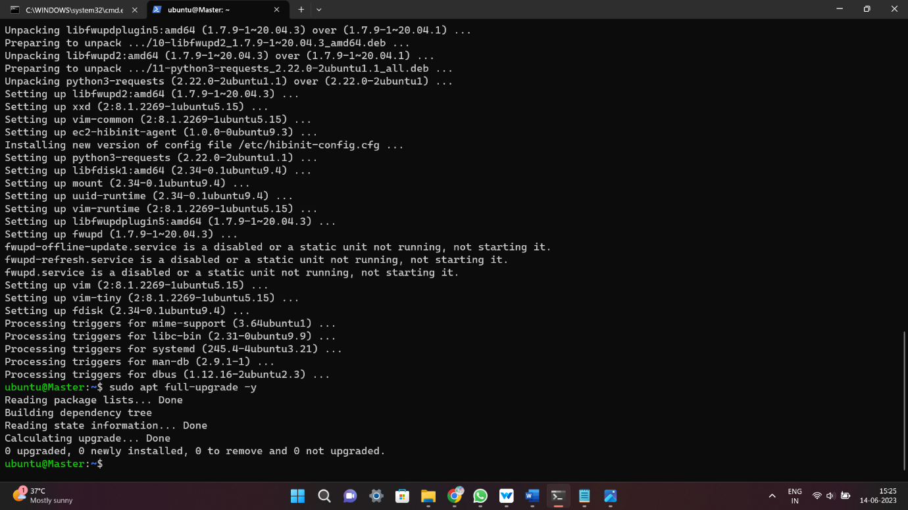

Configure Jenkins Slave Node:

1. Create User, ssh keys and copy it to authorized_keys.

* sudo apt install default-jre -y
* sudo adduser slave1
* sudo su slave1
* ssh-keygen -t rsa -N “ ” -f /home/slave1/.ssh/id_rsa
* cd .ssh/
* cat id_rsa.pub > authorized_keys
* chmod 700 authorized_keys

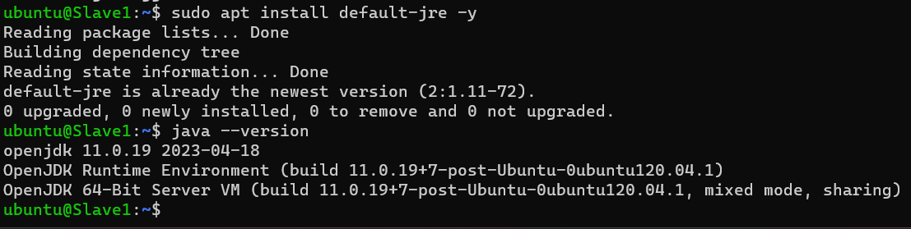

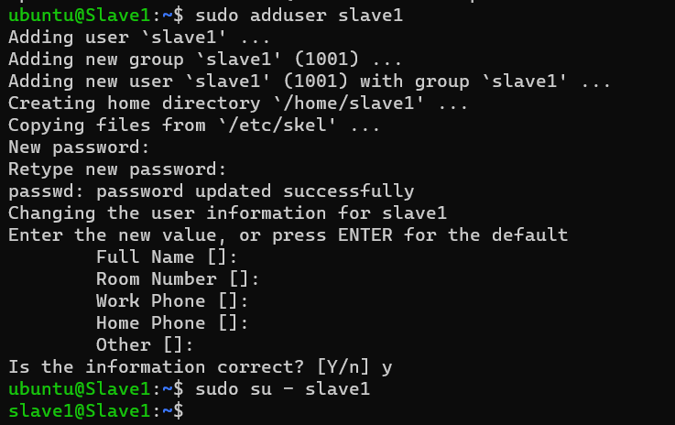

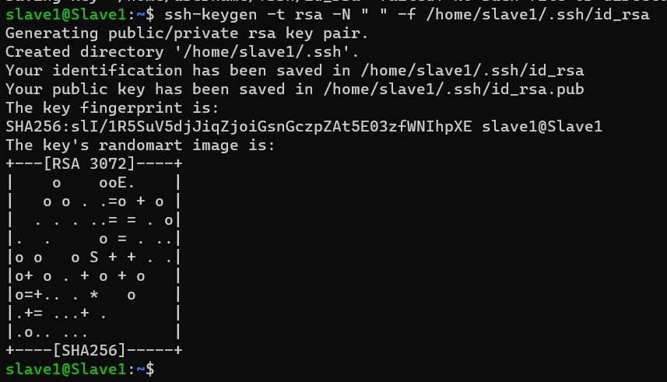

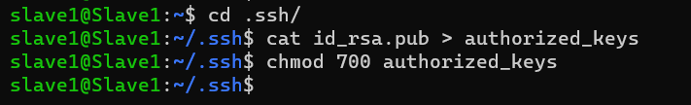

Configure Jenkins Master Node:

1. Copy the Slave node’s public key to master node’s known_hosts file

* sudo apt install default-jre -y
* curl -fsSL https://pkg.jenkins.io/debian/jenkins.io-2023.key | sudo tee \
* /usr/share/keyrings/jenkins-keyring.asc > /dev/null
* echo deb [signed-by=/usr/share/keyrings/jenkins-keyring.asc] \
* https://pkg.jenkins.io/debian binary/ | sudo tee \
* /etc/apt/sources.list.d/jenkins.list > /dev/null
* sudo apt-get update
* sudo apt-get install Jenkins
* sudo mkdir -p /var/lib/Jenkins/.ssh
* cd /var/lib/Jenkins
* sudo chmod 777 .ssh/
* cd .ssh/
* sudo ssh-keyscan -H SLAVE_NODE_PRIVATE_IP >>/var/lib/Jenkins/.ssh/know_hosts
* sudo chown 700 known_hosts

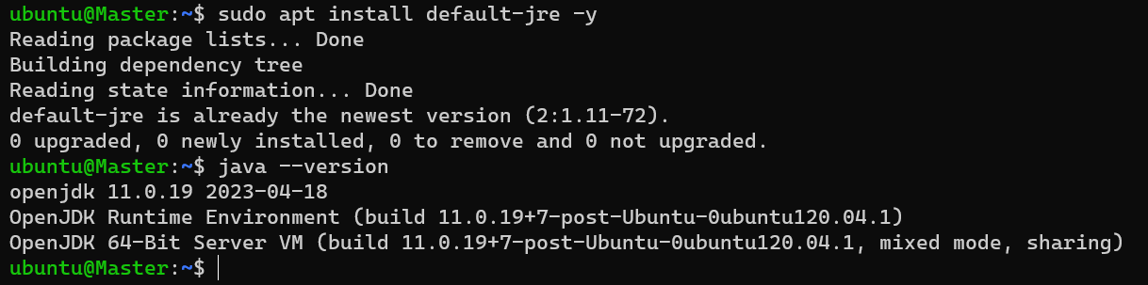

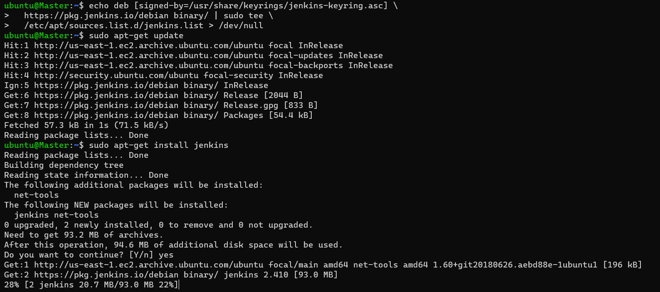

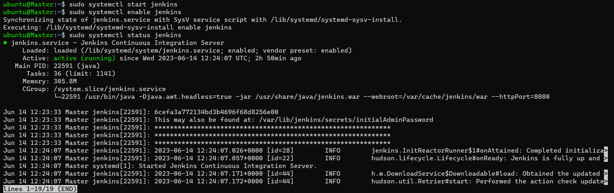

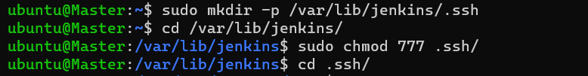

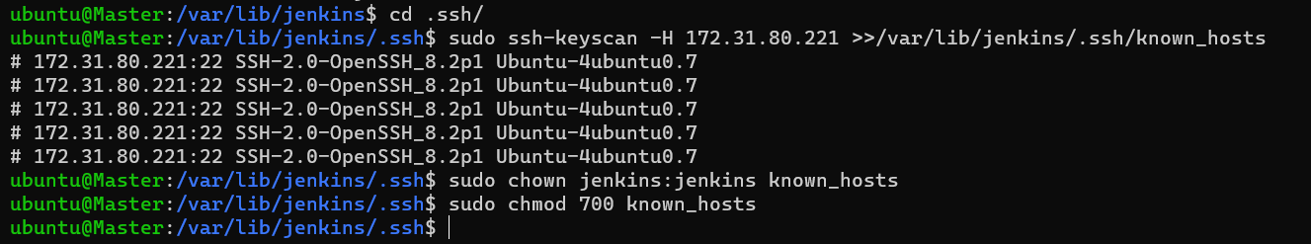

1. Open Console

* Select the instance and select security groups

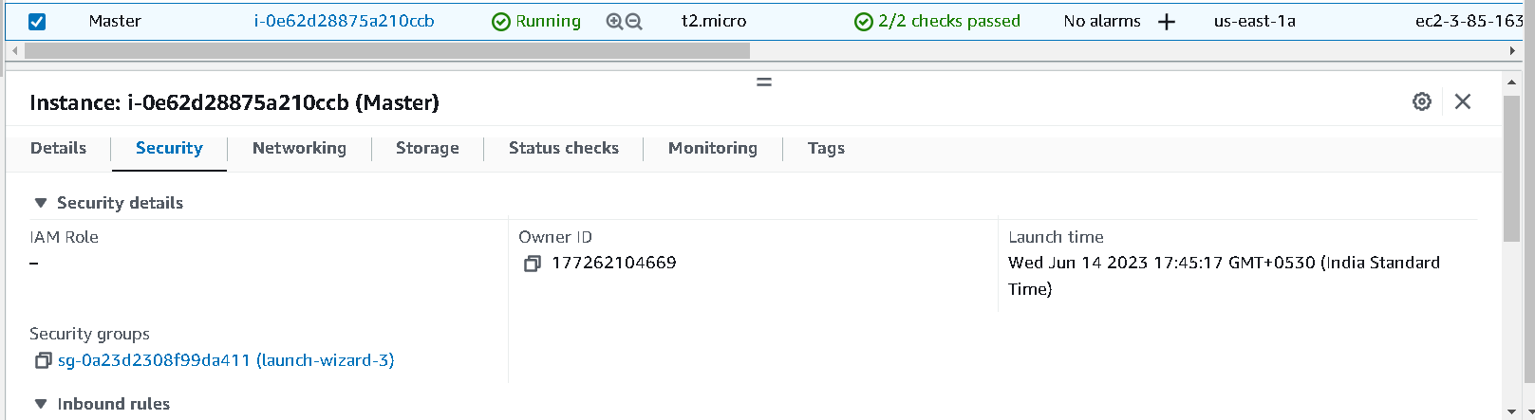

* Inside security group select inbound rules, select edit inbound rules

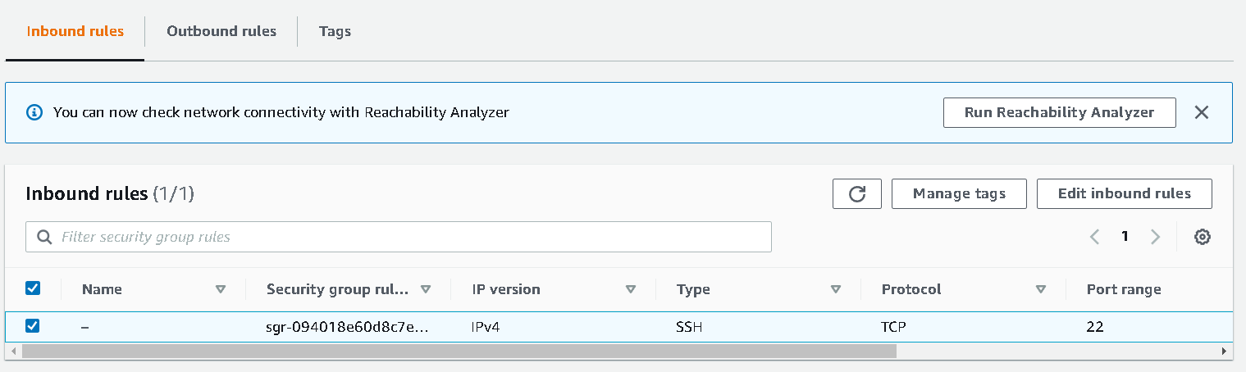

* In inbound rules select - add rule

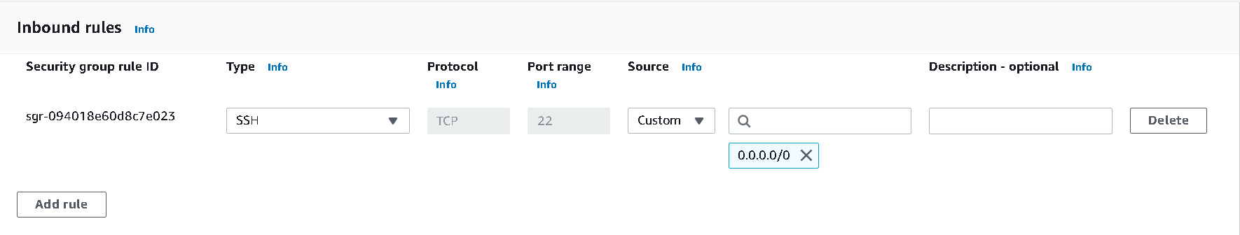

* After click add rule, give type = custom type, port range= 8080, source = Anywhere ip4 (0.0.0.0/0) now save the rules

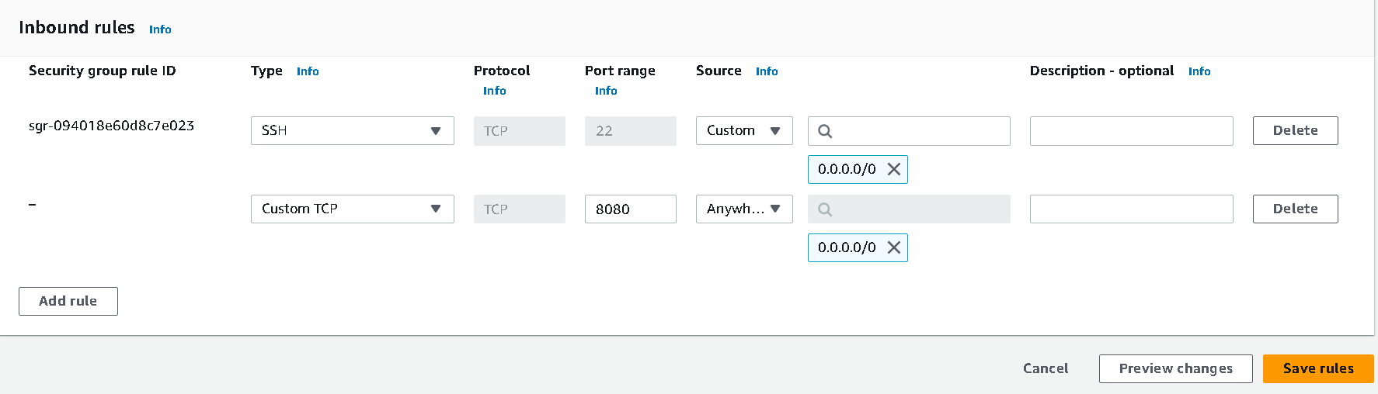

1. Select the public ip4 address

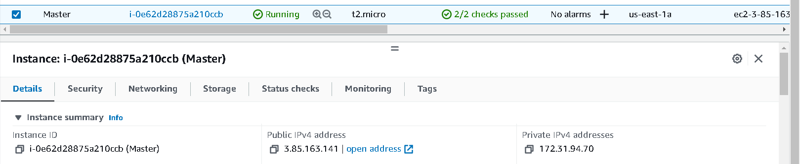

1. Browse the ip4:port8080

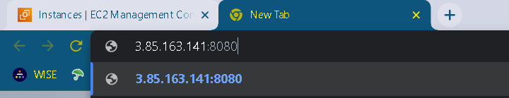

1. Now Jenkins is getting ready

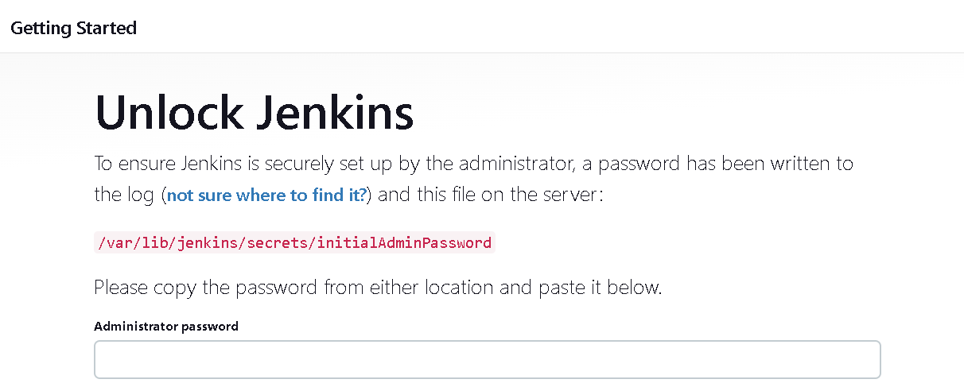

1. To now the password goes into the path

* sudo cat /var/lib/Jenkins/secrets/initialAdminPassword
* copy and paste the password and click continue



1. Select install suggested plugins

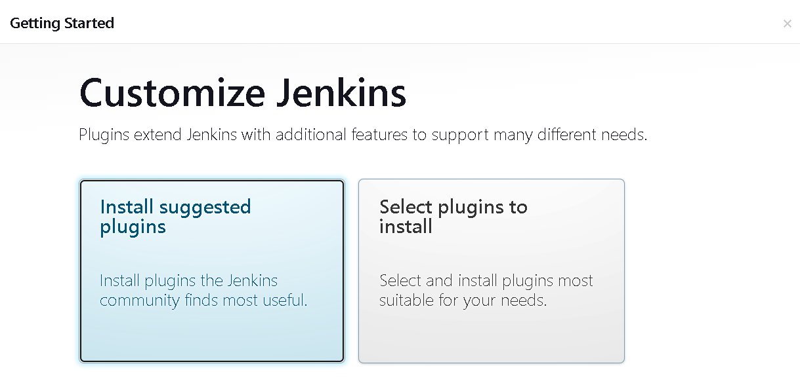

1. Installed suggested plugins

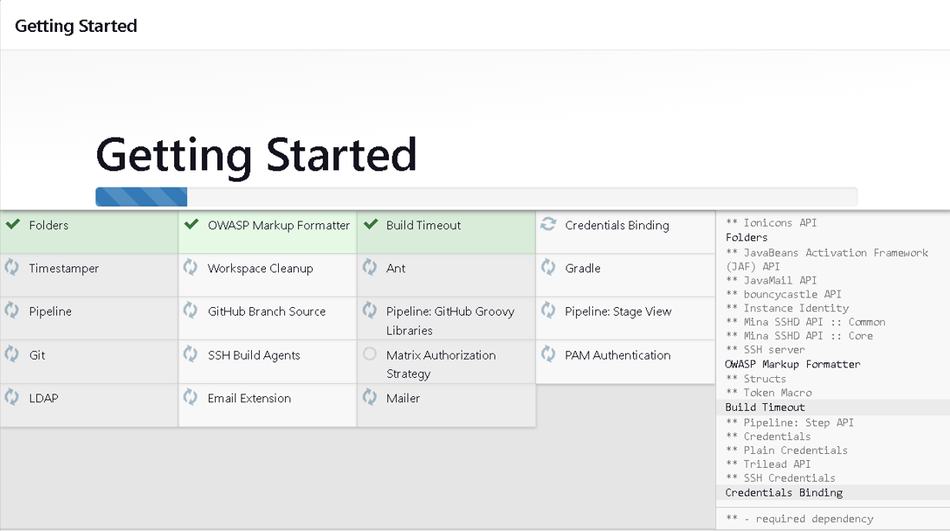

1. Create admin user and Password for login purpose and click save & continue

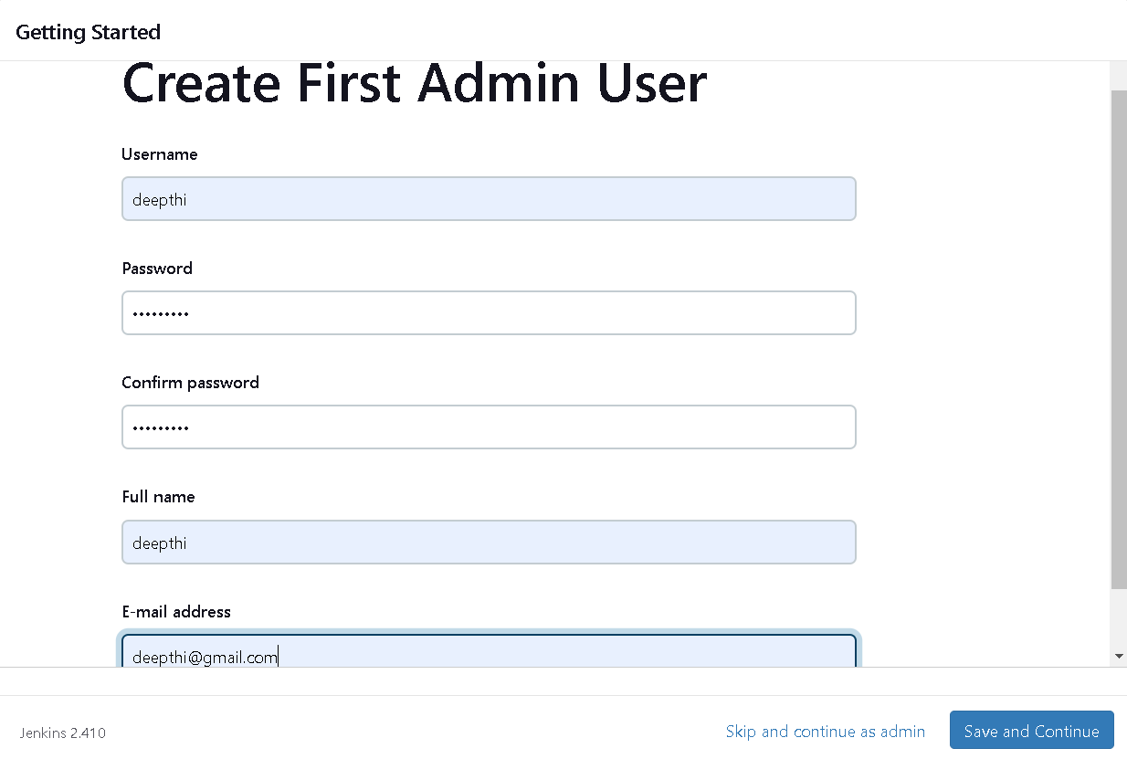

1. Configure the path and finish setup

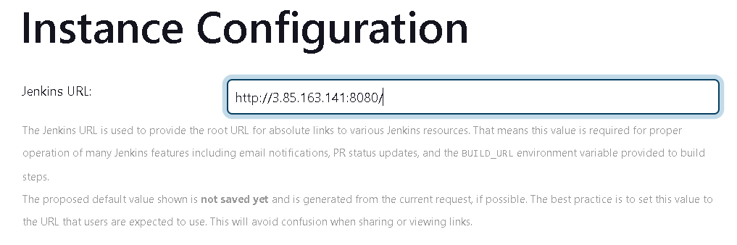

1. Jenkins is Ready now!



1. Select Mange Jenkins and click nodes (Node configuration).

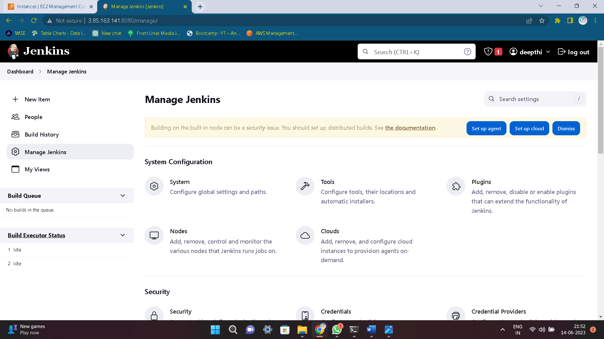

1. Select New node

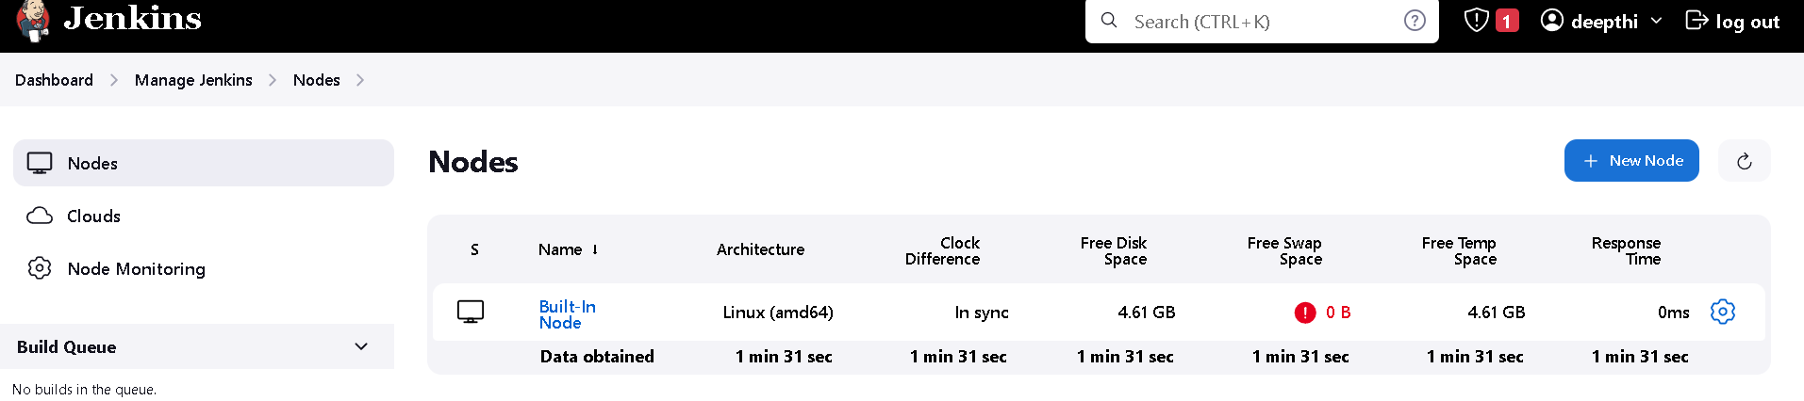

1. Give a node name, select type and then create

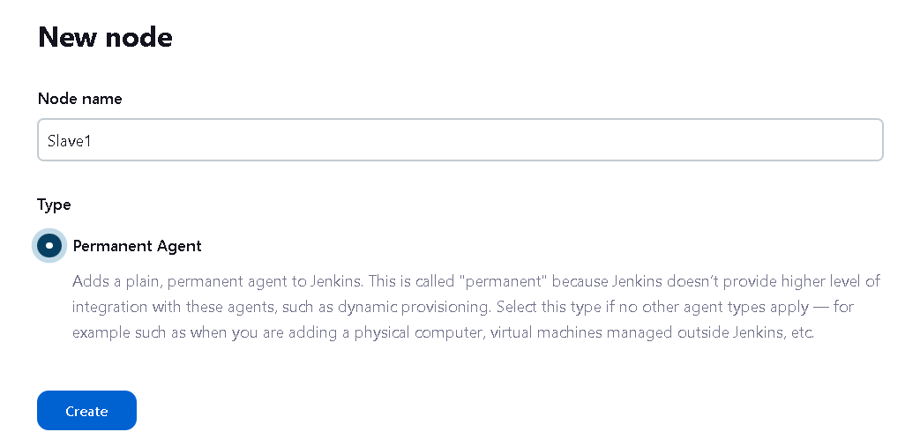

1. Give name and Description is optional , give number of executors and remote root directory

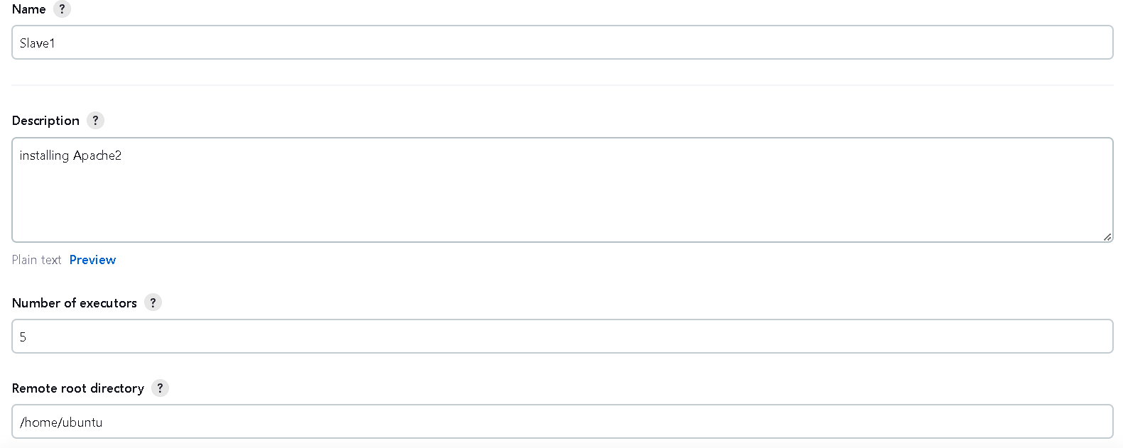

1. Give label name and launch method is via ssh , host = instance private ip4 and add credentials

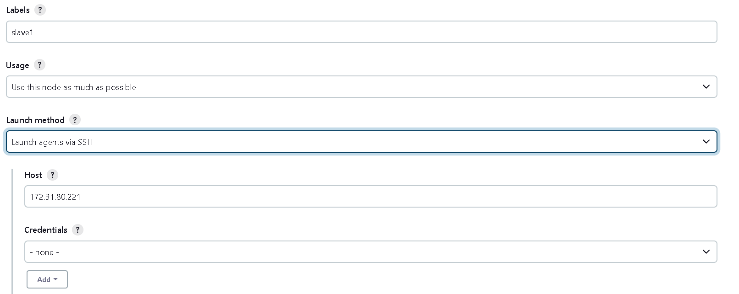

1. Adding credentials by using ssh key

* Kind – select ssh username with private key
* Give an id name and username
* Select Private key and enter directly by using pem file
* Add these credentials
* Save the node

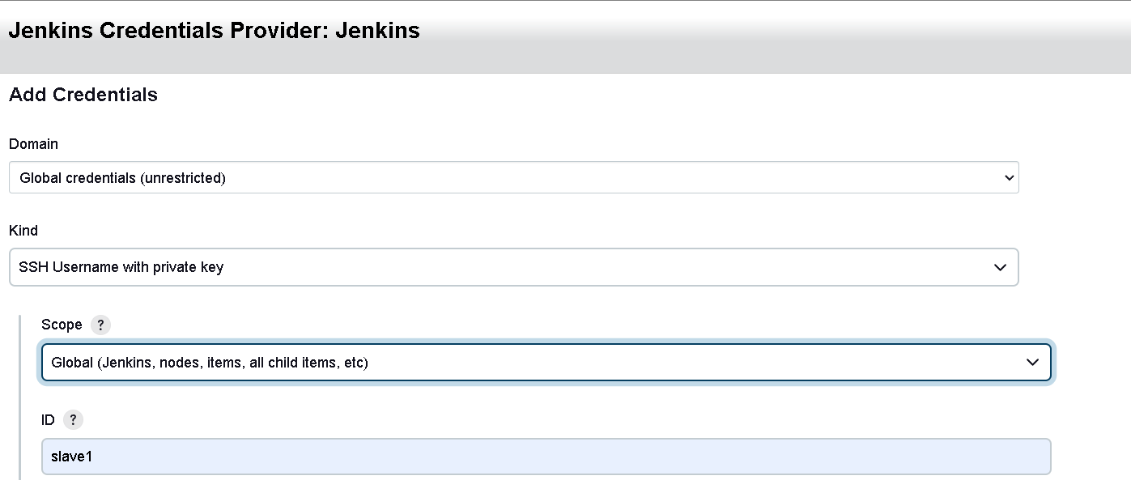

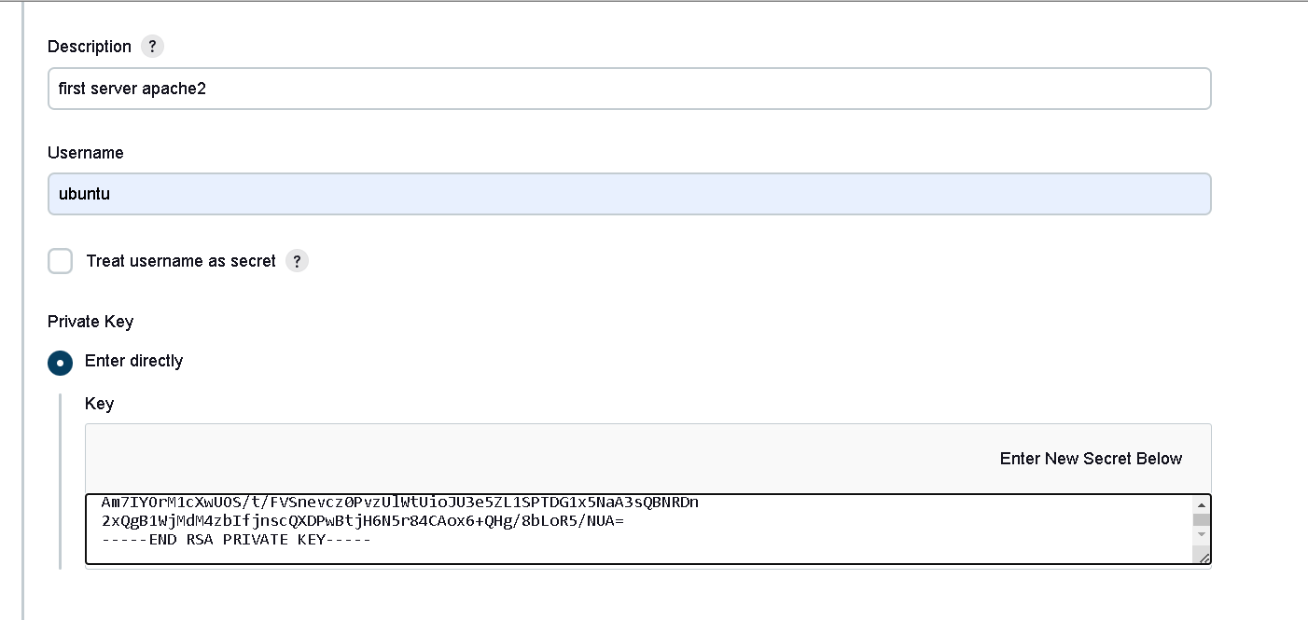

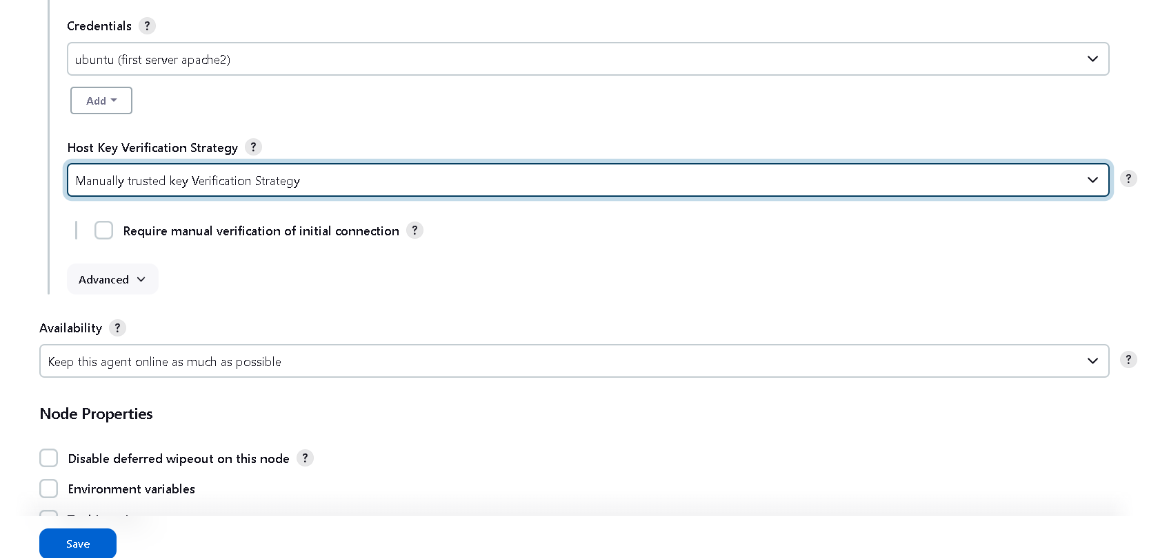

1. Node is created. check the log the node is online or not.

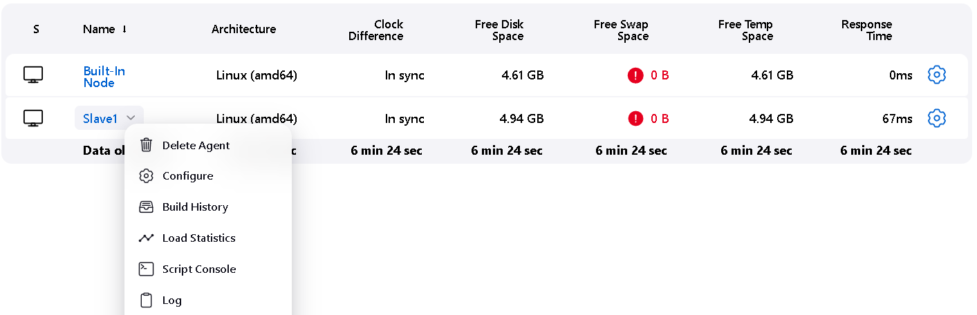

1. Successfully the node is online

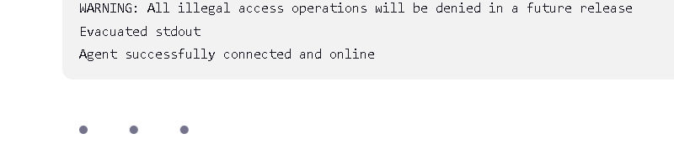

1. Go to dashboard and select new item

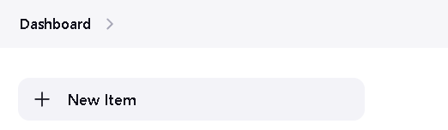

1. Now create a free style project, enter a name and select free style project and save it.

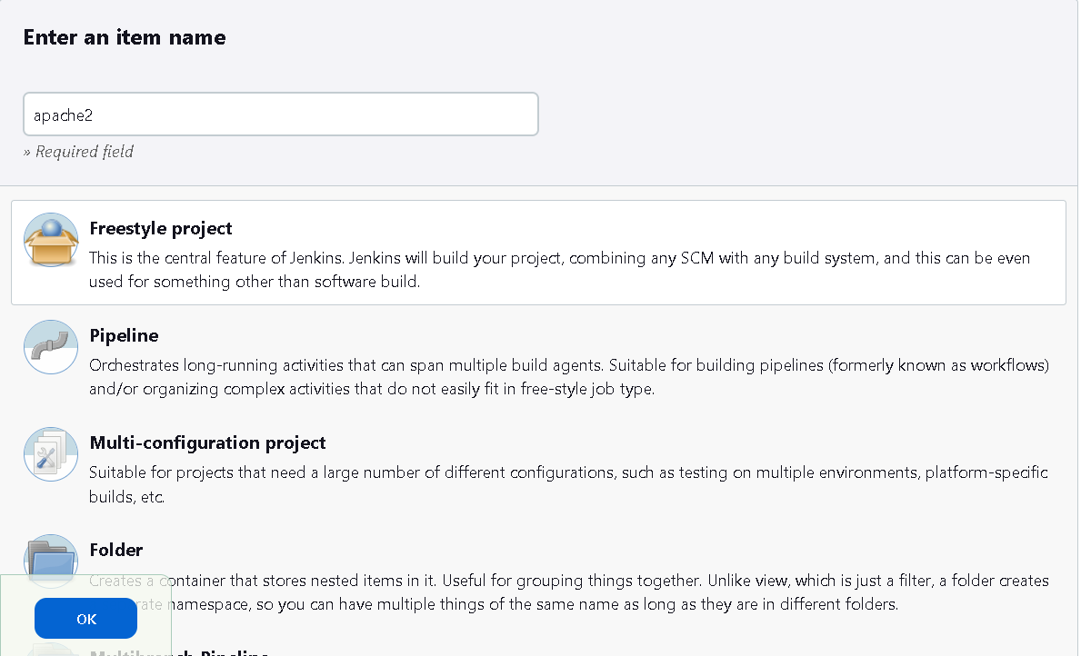



1. Select this option for doing the work on slave1 node

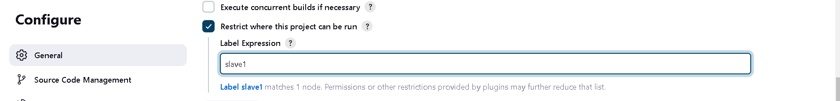

1. Now select the build steps – select execute shell

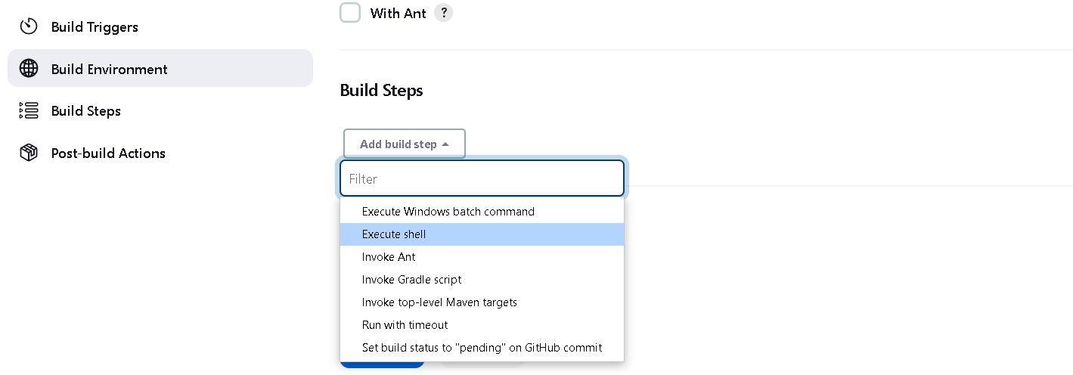

1. Enter commands in execute shell and save this

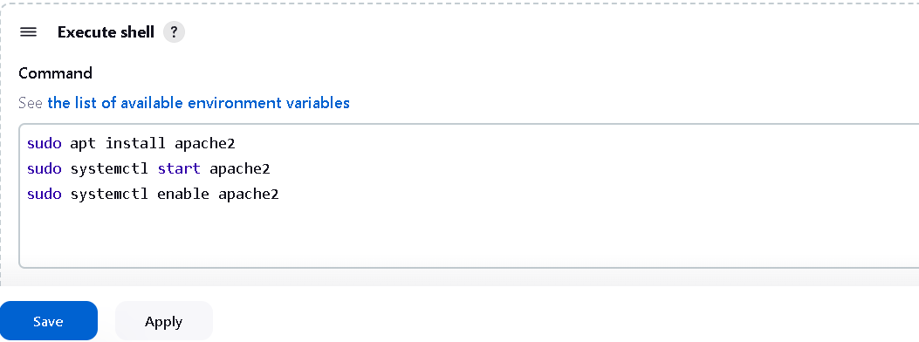

1. Build the project

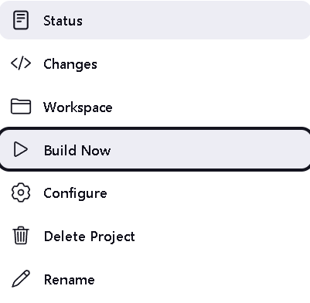

1. Console output is success

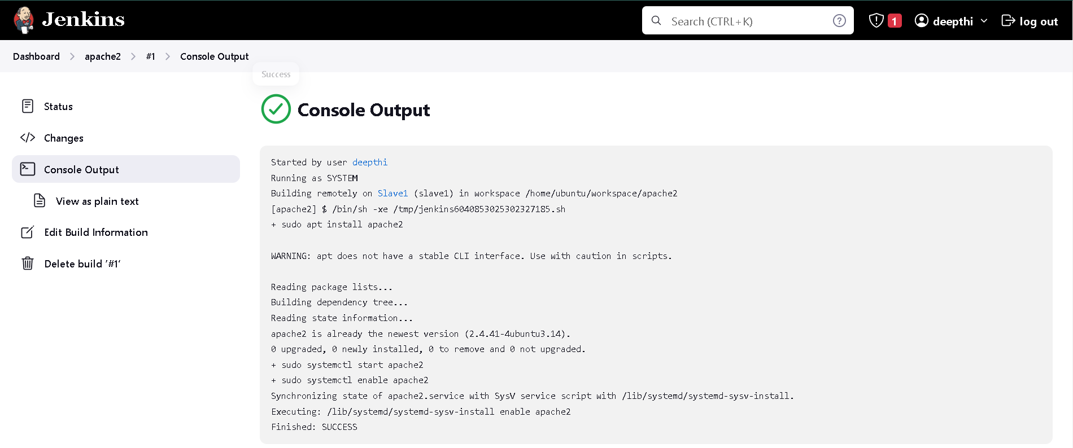

1. Now go to console

* Select slave node and add port 80 in inbound rule

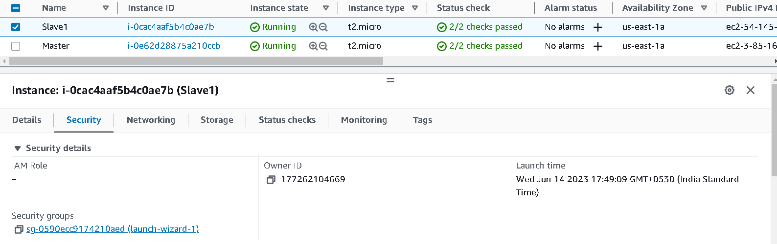



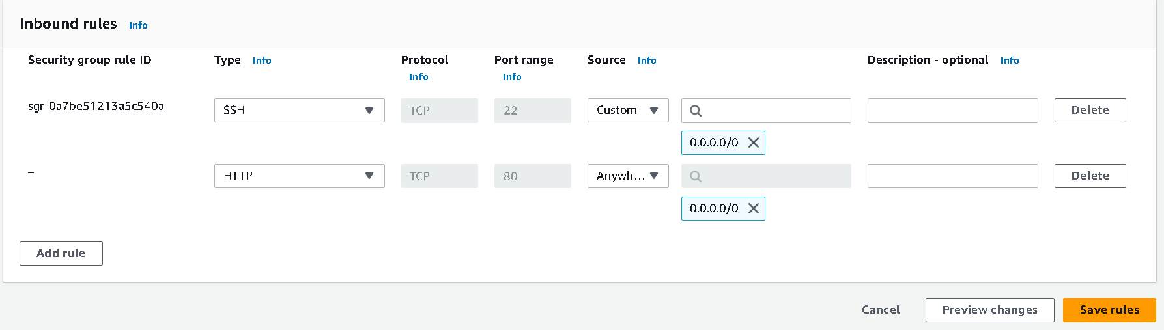

1. Copy the slave public ip4 address and assign apache2 port and browse it Public ipv4 : apache port 80

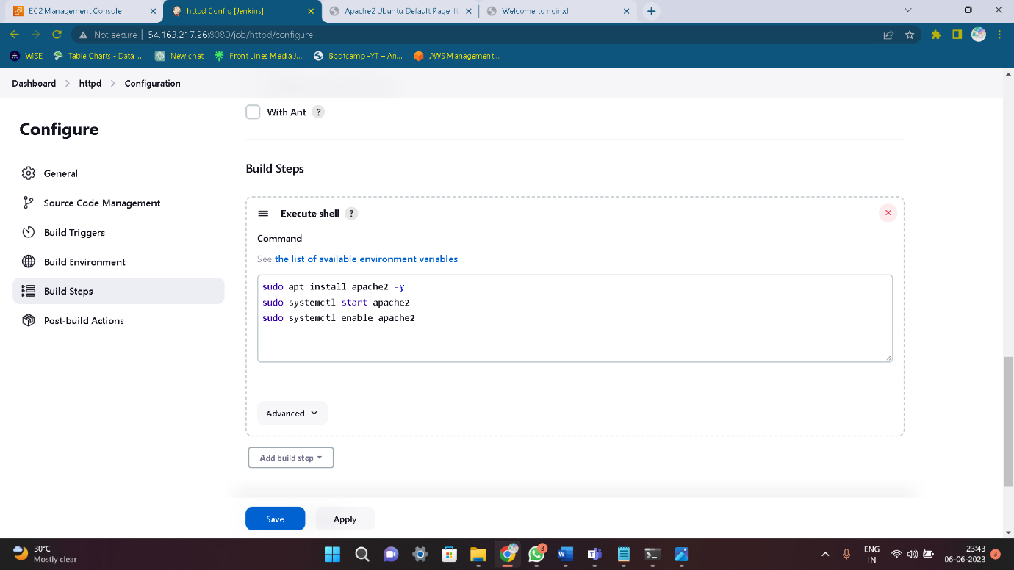

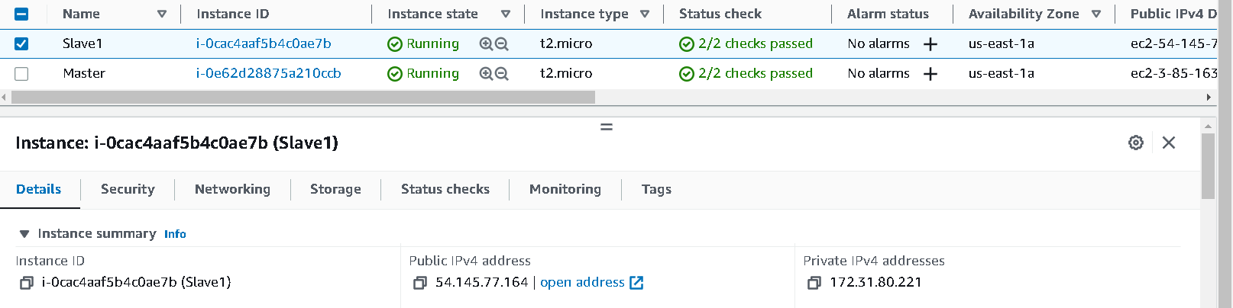

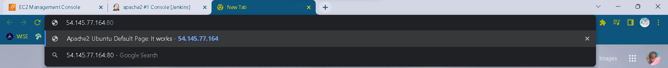

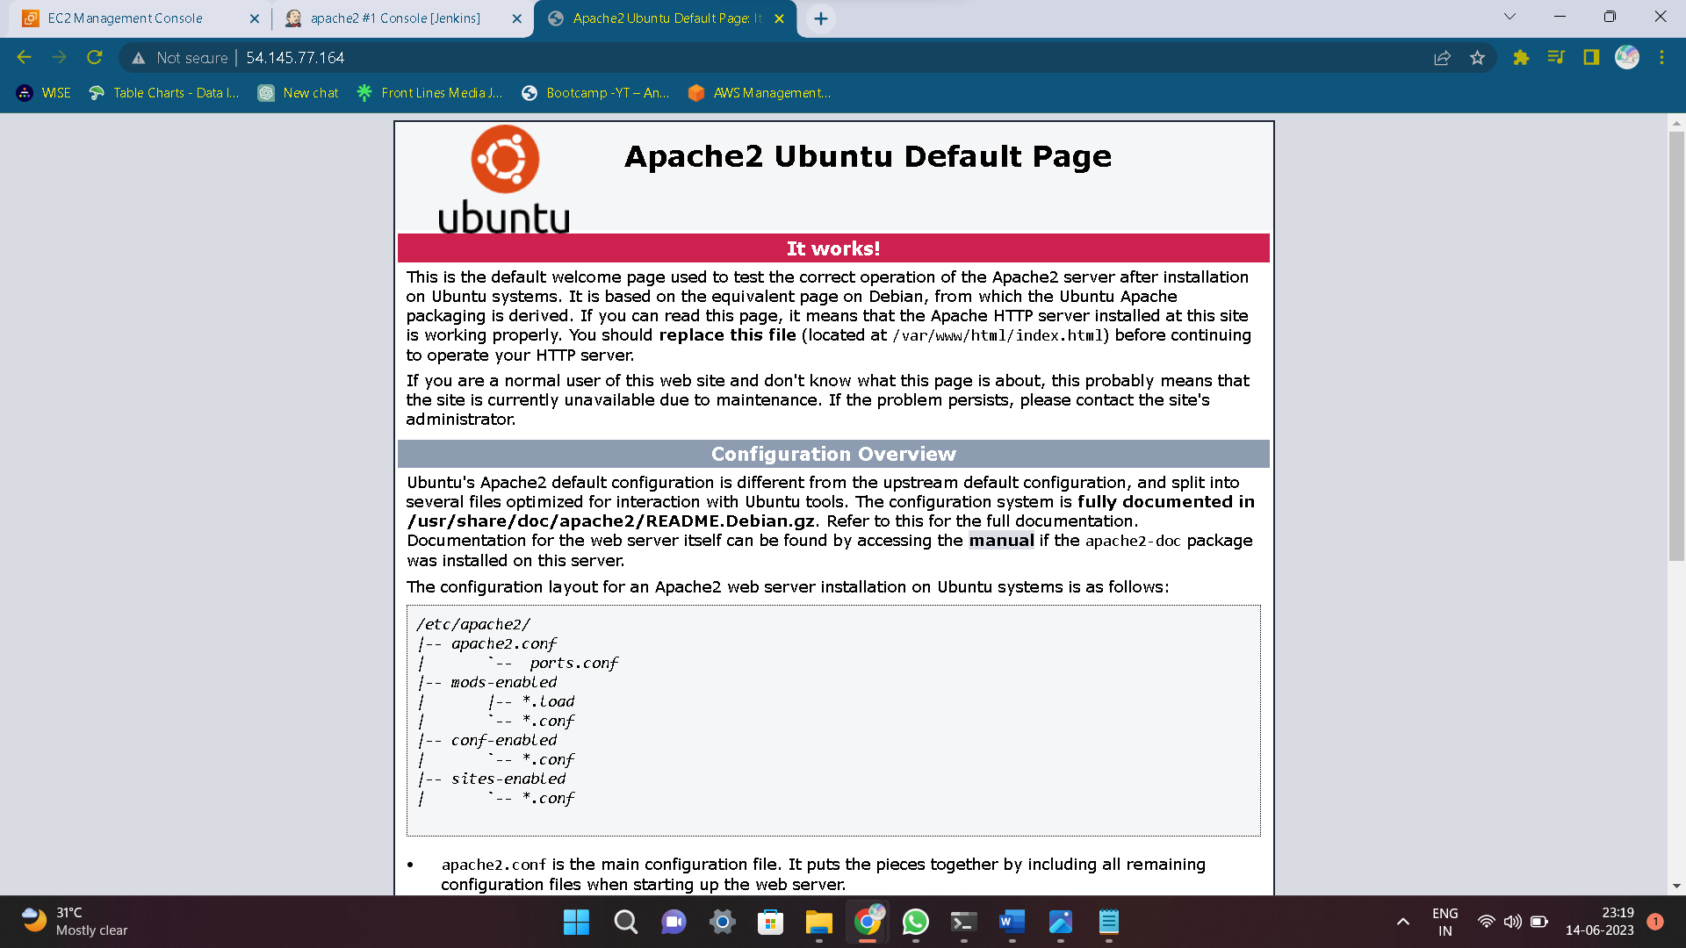

1. Same like as we deploy multiple applications like Nginx , Jenkins , Sonar cube and Tomcat

* Nginx

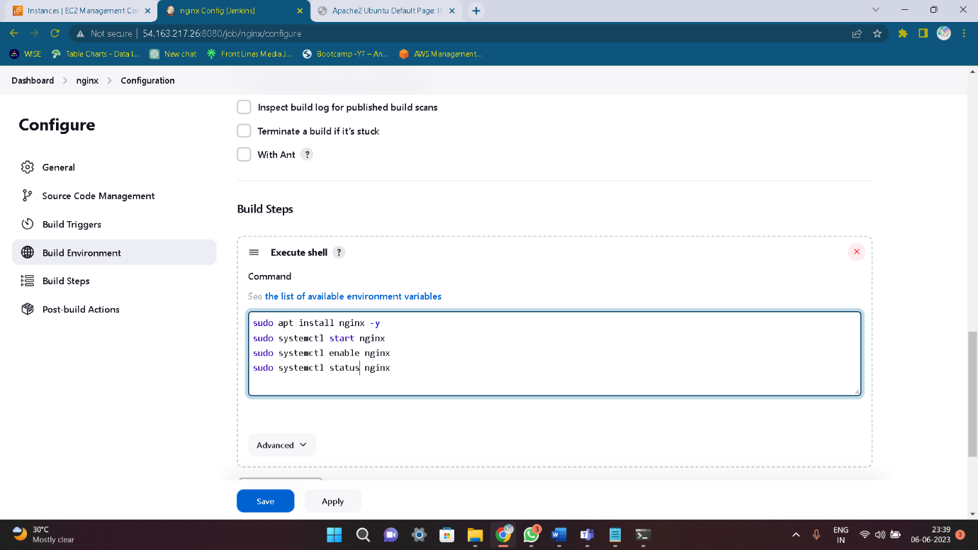

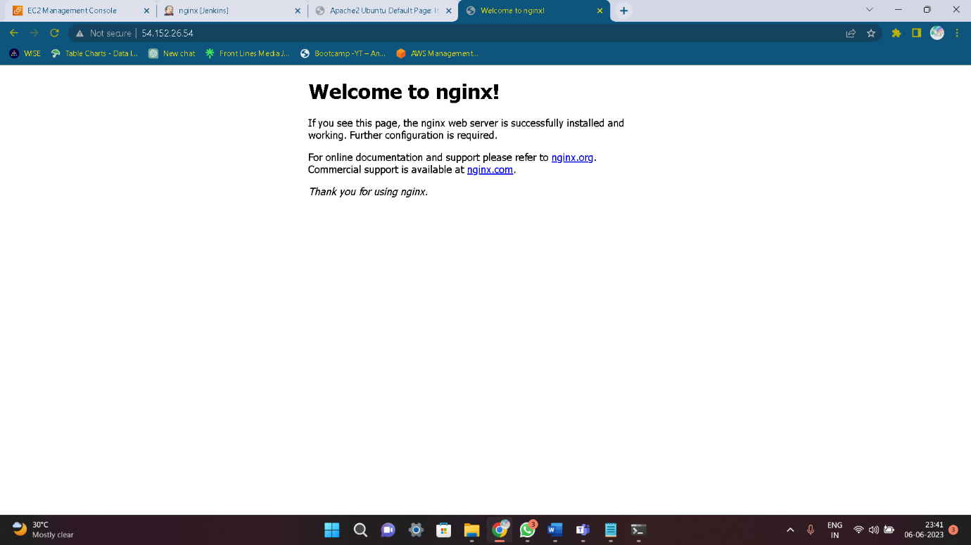

* Tomcat

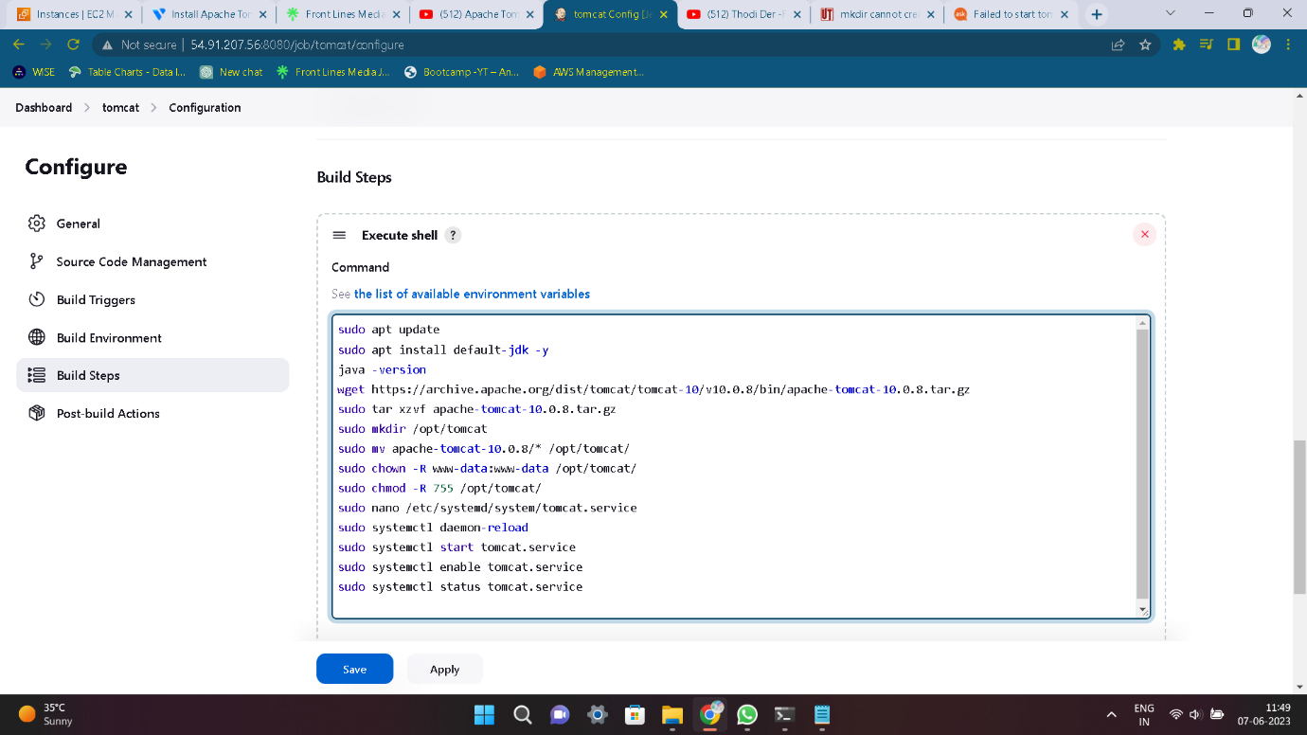

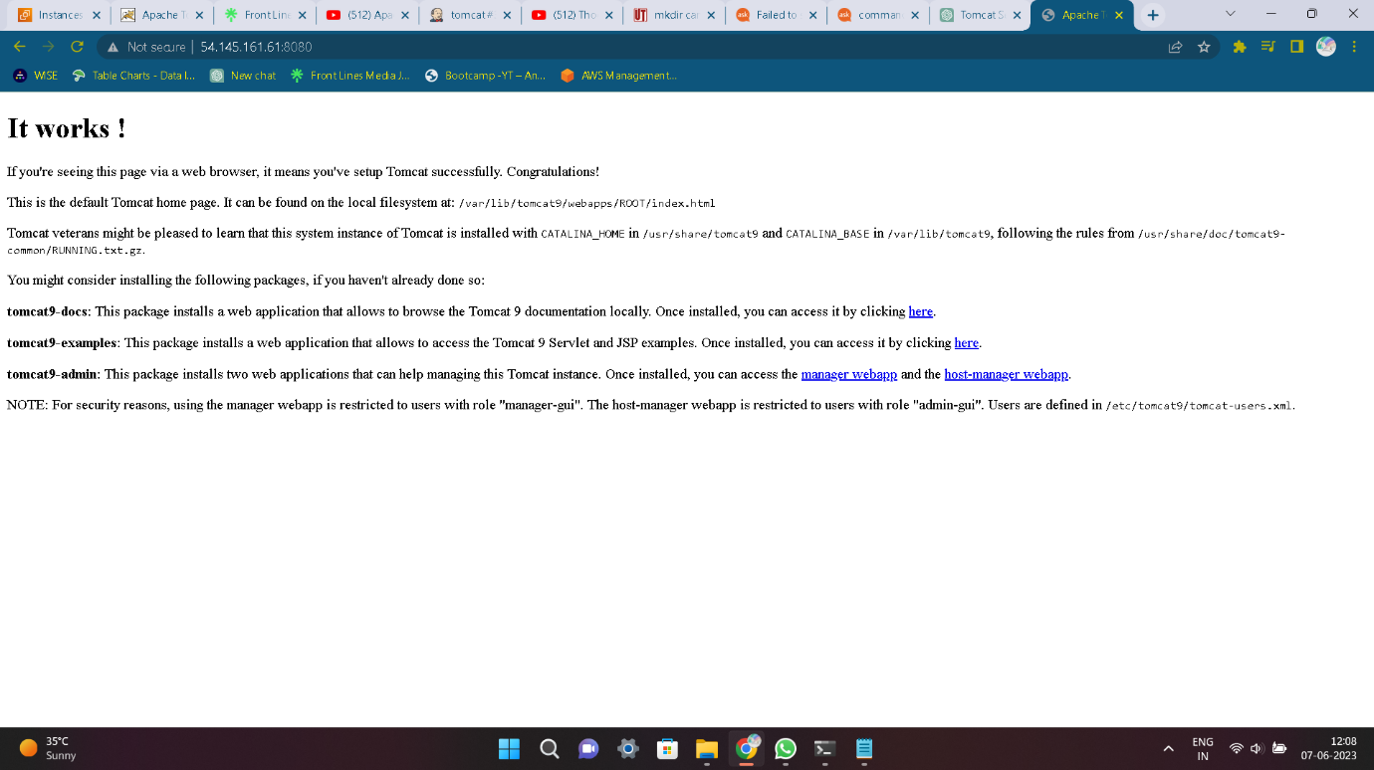

* Jenkins

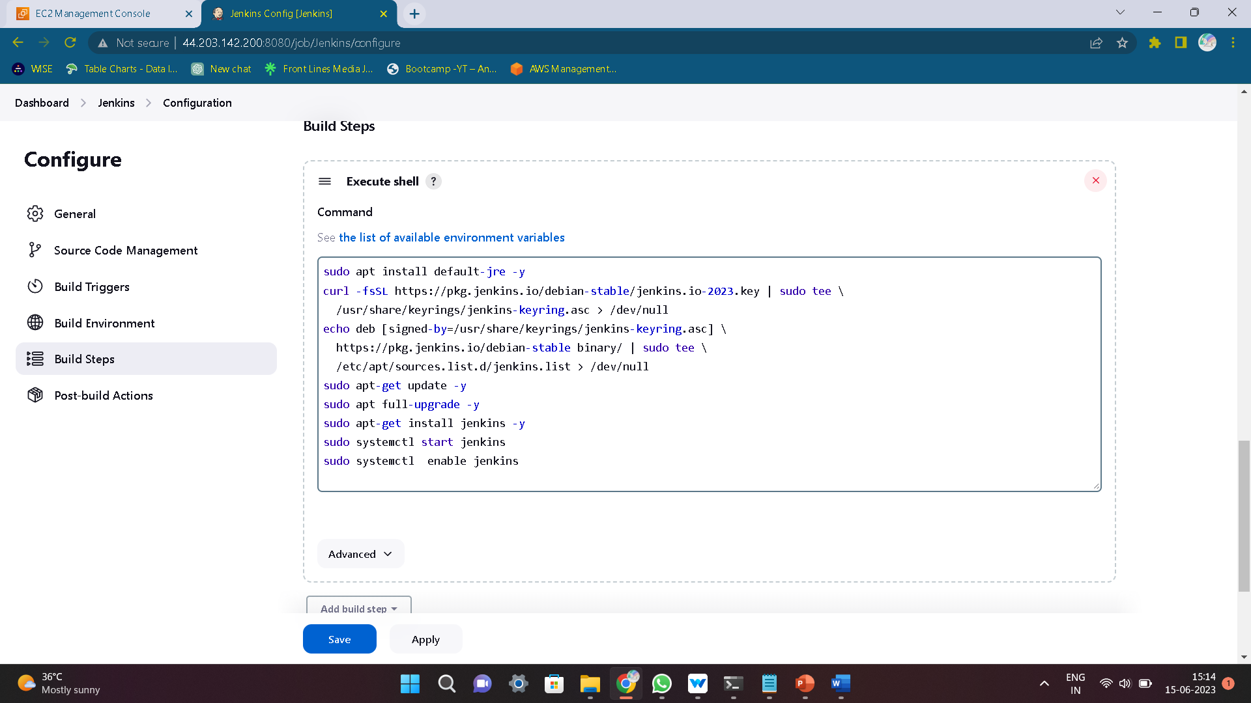

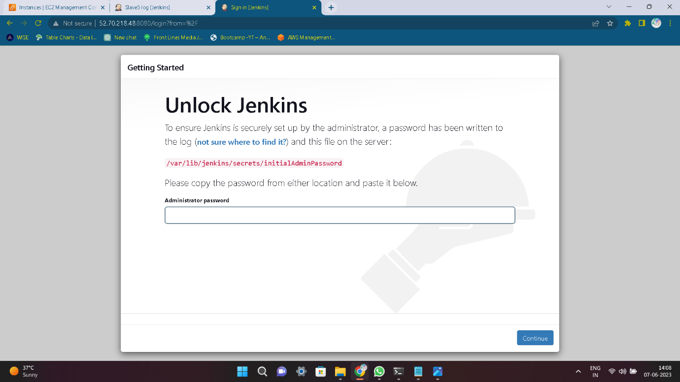

* Sonar cube

